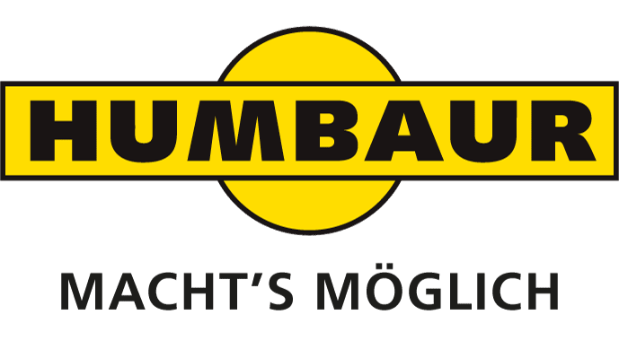
HUMBAUR FLEXBOX: FREEZER BOX NOW ALSO ON TRUCK CHASSIS
Monika Niederreiner
Head of Corporate
Communication

Humbaur GmbH
Mercedesring 1
86368 Gersthofen
Germany

Phone +49 821 24929-532
Fax +49 821 24929-500
m.niederreiner@humbaur.com
www.humbaur.com

Gersthofen, 17. September 2018

Gersthofen, September 19, 2018

As one of the trade fair highlights at the IAA Commercial Vehicles, Humbaur presents the new FlexBox Freeze freezer box on truck chassis from 20 to 27 September 2018. Customers will also benefit from the new breakdown service Humbaur 24/7, in which Humbaur cooperates with the German automobile club ADAC Truckservice.

Humbaur has extended the range of its FlexBox box bodies: these are now also available on truck chassis. The FlexBox box bodies are divided into three series: Dry, Cool and Freeze. What they all have in common is the payload-optimised design and a variety of installation and expansion options. The FlexBox range now encompasses more than 230 series models, offering industry-specific solutions for every need.
Exhibits which Humbaur is displaying for the first time at IAA Commercial Vehicles 2018 include a FlexBox Freeze freezer body fitted to a MAN TGL HGV chassis. The vehicle is equipped with a stainless steel rear portal and a Bär liftgate. It features a Carrier Supra refrigeration unit with Prevention Service monitoring module (more on this in the dedicated section below), internal equipment includes a baffle circulation wall and a cold curtain at the rear. A number of stainless steel track rails allow cargo to be secured, while the floor features an aluminium Gripster layer instead of anti-slip flooring. The rounded corners of the body not only look sleek and modern, they also enhance the vehicle's aerodynamics and help to reduce fuel usage.
The temperature-controlled FlexBox Cool and FlexBox Freeze variants have an ATP certificate. This certifies that the Humbaur vehicle bodies are suitable for transporting perishable food according to the ATP class. All FlexBox Cool bodies consist of 60-mm sandwich panels and a 65-mm insulated floor. In all temperature-controlled bodies (FlexBox Cool and FlexBox Freeze), the rear portal is made from stainless steel as standard and the auxiliary frame is hot-dip galvanised. In the FlexBox Freeze bodies, the front wall and roof are made of 80-mm-thick insulated panels, the side walls from 65-mm panels and the insulated floor measures 120 mm. The double-hinged rear doors are 85-mm thick.
The FlexBox Cool and Freeze variants can be optionally equipped with the new LightGrip floor. This provides a weight-optimised design with integrated aluminium crossbars. The lightly textured plastic surface is suitable for use with foodstuffs in accordance with HACCP, with the rough surface helping to secure loads. Using the LightGrip floor allows the payload to be increased in vans and lightweight HGVs weighing up to 7.5 t.

Service: Humbaur 24/7

Since July, the Humbaur 24/7 breakdown assistance service has been available in Germany for all FlexBox vehicles—regardless of the manufacturer of the chassis—as well as for the manufacturer's flatbed trailers. The service will be launched internationally at IAA Commercial Vehicles 2018. This is why Humbaur is the first commercial vehicle manufacturer to work together with the ADAC Truck Service to form a common service network of over 1,200 workshops in Germany and approximately 40,000 workshops throughout Europe.

Humbaur 24/7 provides assistance for any kind of breakdown. For lift platforms, cooling units and the vehicle, access to the respective manufacturer service is also possible. A service customer card contains all important information and questions that you should answer on the hotline in the event of service: for example, chassis number, registration number, problem/defect and other information.
A special optional service is the new Prevention Service from the ADAC Truck Service, which is made possible due to digital monitoring of refrigeration units. With the Prevention Service, buyers of a FlexBox cool or FlexBox Freeze vehicle body receive a new warning function as well as mobile or stationary repairs in Europe. That's why the cooling units of the FlexBox box bodies are equipped with a so-called ID box that transmits the status data via GPS or GSM in real-time on a neutral platform, where it is checked and translated into alerts when necessary. "Green" informs the driver about a deviation from the setpoint value that is not yet critical, "yellow" means that the manufacturer recommends sending the vehicle in for repairs and if "red" is indicated, the driver is sent an acute warning that the vehicle should no longer be driven. Depending on the severity of the threat of damage, the truck service organises immediate mobile use on request or a workshop appointment along the route, before the cooling unit fails and expensive damage occurs as a result.

You too can be a follower!

HUMBAUR is one of the largest suppliers of trailers and vehicle bodies in the world. The owner-managed family company offers around 420 different series models for commercial and private clients and 230 models of its FlexBox box bodies. With 500 employees, around 52,000 trailers are produced at the Gersthofen site per annum—all of which are "Made in Germany". The expert for trailers and transport solutions from 750-kg to 50-t maximum weight is active nationally and internationally and also manufactures special solutions. Over 500 dealers in Germany and 26 other European countries offer local expertise.
Visit us at: www.humbaur.com

